E-Commerce Business Analysis Report
1. Overview
This project analyzes e-commerce transactional data to uncover insights related to customer behavior, product performance, sales trends, and inventory management. The objective is to transform raw business data into actionable recommendations that support data-driven decision-making across marketing, operations, sales, and supply chain functions.
2. Dataset Summary
Dataset Overview:
- Customers Dataset: customer_id, name, and location
- Products Dataset: product_id, name, category, and price.
- Orders Dataset: order_id, order_date, customer_id, and total_amount.
- OrderDetails Dataset: order_id, product_id, quantity, and price_per_unit.
Dataset Size:
- Customers Dataset: (100 x 3)
- Products Dataset: (8 x 4)
- Orders Dataset: (200 x 4)
- OrderDetails Dataset: (200 x 4)

3. Exploratory Data Analysis (Python)
Data Cleaning: All the data are having extra columns and no missing values , so only the extra columns are removed using python(pandas) and then uploaded to MySQL database. Here are the pictures of cleaned and uncleaned data sets
This is customers Raw and Cleaned:-
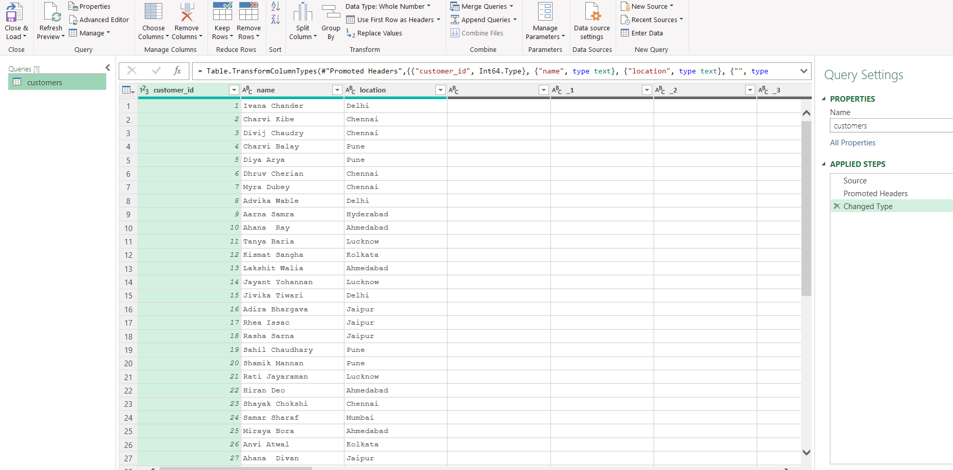
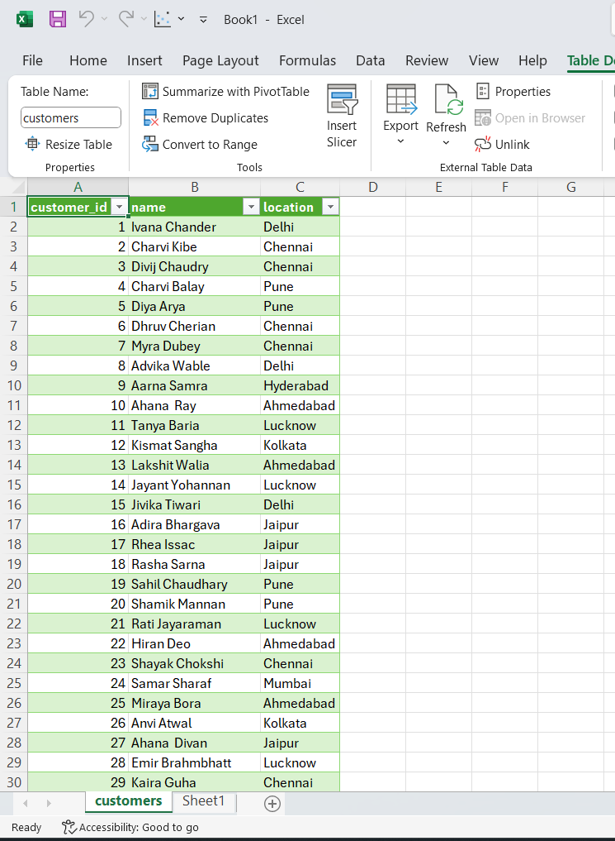
This is the OrdersDetails Raw vs cleaned:-
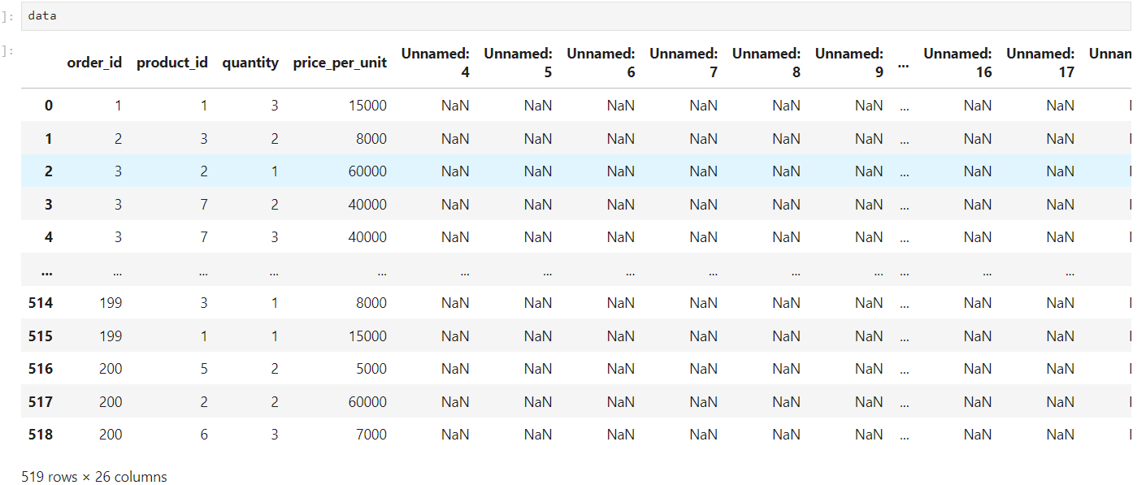
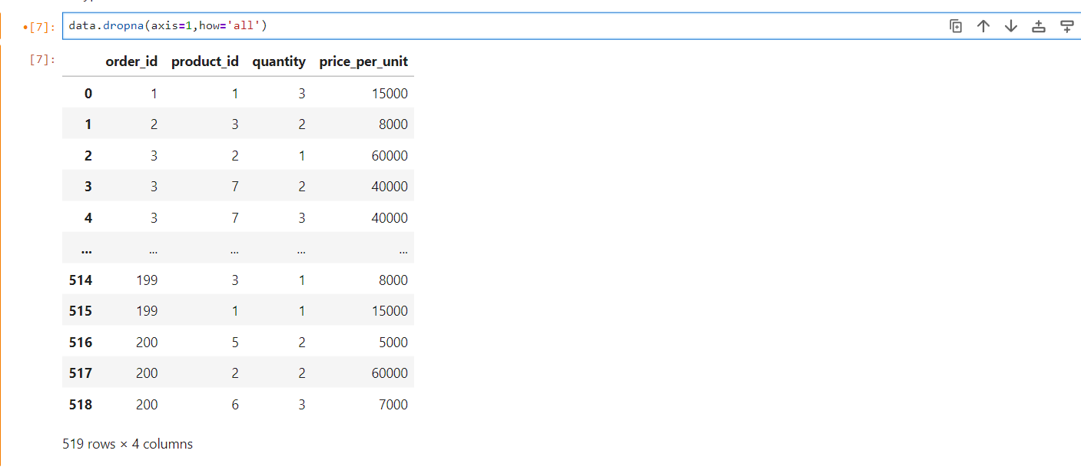

This is the Orders dataset RAW vs Cleaned:-
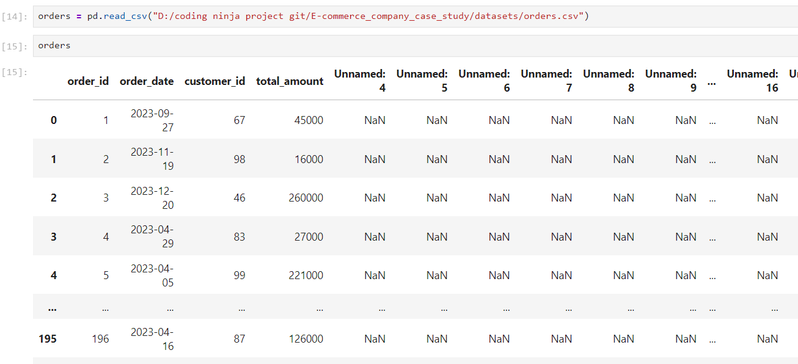
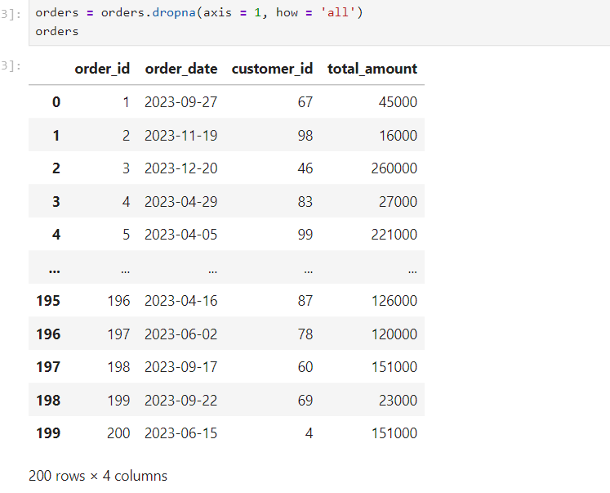
This the Products dataset RAW vs Cleaned: -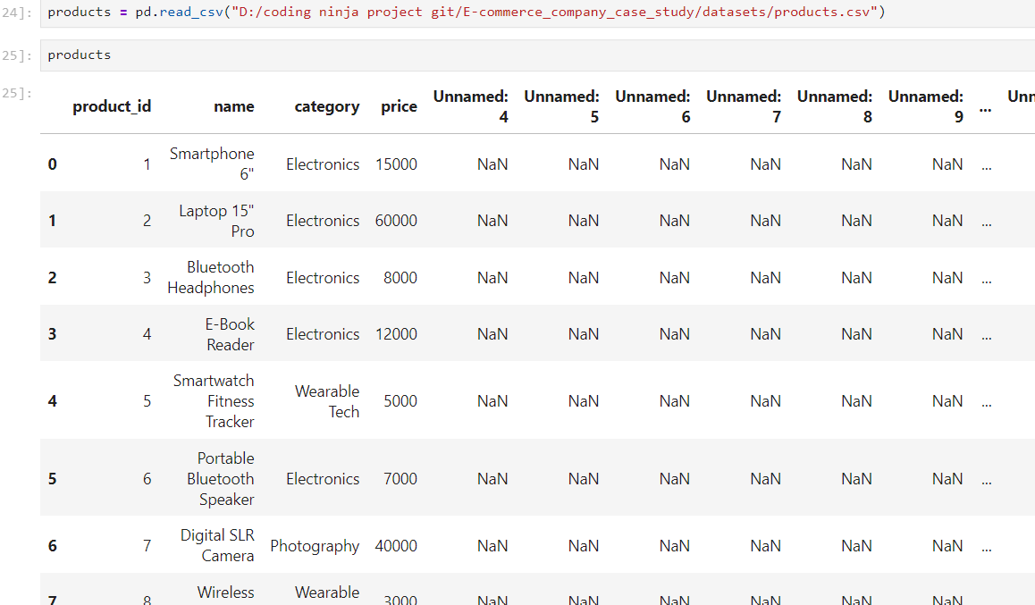
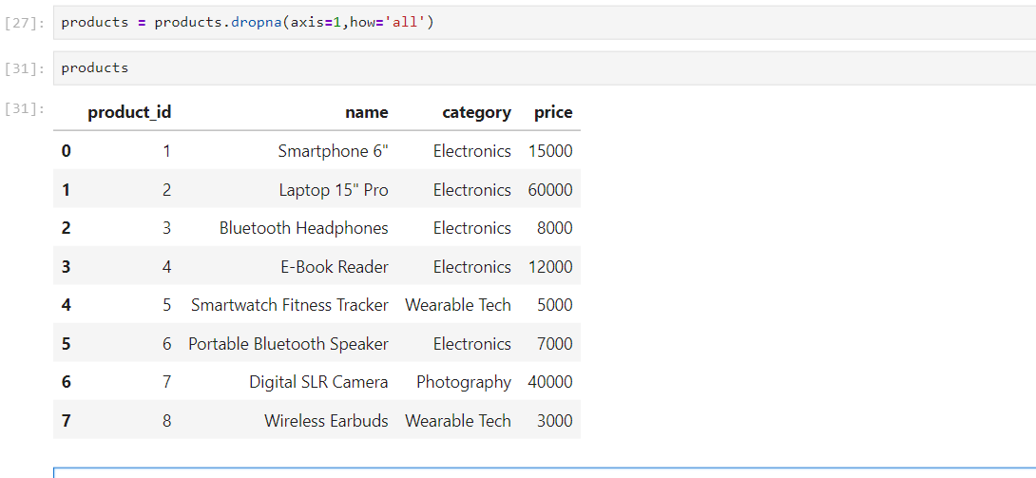
4. SQL Business Analysis & Insights
The core business analysis was conducted using SQL queries to answer practical business questions.
CUSTOMER INSIGHTS
1. Customer Concentration Analysis
Business Question:
- Which cities have the highest concentration of customers for targeted marketing and logistical optimization?
location | number_of_customers
Delhi | 16
Chennai | 15
Jaipur | 11
Pune | 10
Ahmedabad | 10

Business Value:
Business Recommendation: Prioritize Delhi and Chennai for localized campaigns, regional offers, and faster delivery coverage. Use city-wise promotions to expand the strongest clusters first, then test smaller campaigns in emerging locations such as Jaipur and Pune.
2. Customer Order Frequency Analysis
Business Question:
- What is the distribution of customer order frequencies across our platform?
NumberOfOrders | CustomerCount
1 | 26
2 | 26
3 | 18
4 | 6
5 | 6
6 | 1
8 | 1

Business Value:
Convert one-time buyers into repeat buyers with post-purchase email flows, second-order coupons, and a simple loyalty program. Customers with 1-2 orders should be the main retargeting audience because they represent the biggest retention opportunity.

3. New Customer Acquisition Analysis
Business Question:
- How successful are our marketing and market expansion efforts at acquiring entirely new customers month-over-month?
FirstPurchaseMonth | TotalNewCustomers
01-03-2023 | 11
01-04-2023 | 18
01-05-2023 | 11
01-06-2023 | 8
01-07-2023 | 11
01-08-2023 | 9
01-09-2023 | 5
01-10-2023 | 3
01-11-2023 | 1
01-12-2023 | 4
01-01-2024 | 2
01-02-2024 | 1

Business Value:
Scale the channels that drove the April and early-year acquisition spikes, then investigate why acquisition fell after mid-year. Keep a steady always-on acquisition funnel and run stronger campaigns during weaker months to avoid long gaps in new customer growth.

PRODUCT ANALYSIS
4. Revenue Contribution Analysis
Business Question:
- Which products generate the highest revenue?
Product_id | Product_Name | TotalPrice
2 | Laptop 15 Pro" | 7560000
7 | Digital SLR Camera | 6040000
1 | Smartphone 6",1620000  4,E-Book Reader" | 1560000
3 | Bluetooth Headphones | 1080000
6 | Portable Bluetooth Speaker | 938000
5 | Smartwatch Fitness Tracker | 595000
8 | Wireless Earbuds | 390000

Business Value:
Protect the top revenue drivers, especially Laptop 15 Pro and Digital SLR Camera, with higher inventory priority, premium placement, and accessory bundles. Lower-revenue items should be promoted through cross-sells and combo deals so they contribute more to basket value.

5. Market Basket Analysis
Business Question:
- Which products are commonly purchased together?
Product1 | Product2 | Times_Bought
7 | 8 | 20
3 | 7 | 19
2 | 5 | 17
6 | 7 | 17
1 | 5 | 14
2 | 7 | 14
3 | 4 | 14
4 | 7 | 14
4 | 8 | 14
5 | 6 | 14
5 | 8 | 14
1 | 4 | 13
1 | 8 | 13
2 | 3 | 13
2 | 4 | 13
3 | 6 | 13
1 | 3 | 12
2 | 6 | 12
3 | 5 | 12
1 | 2 | 11
1 | 7 | 11
3 | 8 | 11
4 | 6 | 11
1 | 6 | 10
2 | 8 | 10
4 | 5 | 10
5 | 7 | 9
6 | 8 | 6

Business Value:
Turn the strongest product combinations into bundles and recommendation widgets at checkout and on product pages. Pairs that appear frequently together should receive combo pricing, add-on discounts, and automated cross-sell suggestions.

6. High-Value Product Pair Analysis
Business Question:
- What are our top-grossing products that customers consistently buy in pairs?
product_id | AvgQuantity | TotalRevenue
1 | 2 | 1620000
8 | 2 | 390000
Here the products which are average quantity is taken as 2 and seen what the total revenue. So, by this we could replicate for 3 and more
Business Value:
Create targeted pair offers for the products that already sell well in quantity two, because they show clear repeat purchase behavior. Use limited-time bundle discounts and checkout prompts to increase the value of each paired purchase.

7. Product Category Reach Analysis
Business Question:
- Which product categories have the widest appeal across our customer base?
category | unique_customers
Electronics | 79
Wearable Tech | 61
Photography | 45

Business Value:
Invest more in Electronics and Wearable Tech because they already have the widest reach. Use Photography as a premium niche category with curated campaigns, while keeping category-wise assortment broad in the most popular segments.

SALES OPTIMIZATION
8. Sales Growth Analysis
Business Question:
- What does our month-over-month sales growth trajectory look like, and are we picking up momentum?
Month | TotalSales | PercentChange
01-03-2023 | 789000 | 0
01-04-2023 | 1704000 | 115.97
01-05-2023 | 1582000 | -7.16
01-06-2023 | 1040000 | -34.26
01-07-2023 | 2568000 | 146.92
01-08-2023 | 1800000 | -29.91
01-09-2023 | 2927000 | 62.61
01-10-2023 | 1497000 | -48.86
01-11-2023 | 1151000 | -23.11
01-12-2023 | 2774000 | 141.01
01-01-2024 | 1555000 | -43.94
01-02-2024 | 396000 | -74.53

Business Value:
Use the strong growth months to replicate the promotion, pricing, and traffic mix that worked best, while setting corrective actions for negative-growth months. The sharp sales swings show a need for better campaign planning, demand forecasting, and promo calendar control.

9. Average Order Value Analysis
Business Question:
- How is our average order value shifting month-over-month, and what does that tell us about our current pricing momentum?
Month | AvgOrderValue | ChangeInValue
01-12-2023 | 132095.24 | 36179
01-04-2023 | 81142.86 | 20451
01-06-2023 | 104000 | 16111
01-08-2023 | 112500 | 13731
01-11-2023 | 95916.67 | 12750
01-09-2023 | 121958.33 | 9458
01-05-2023 | 87888.89 | 6746
01-01-2024 | 129583.33 | -2512
01-07-2023 | 98769.23 | -5231
01-10-2023 | 83166.67 | -38792
01-02-2024 | 44000 | -85583
01-03-2023 | 60692.31

Business Value:
Push upsells, premium bundles, and free-shipping thresholds in low-AOV months to lift basket size. Use the high-AOV months as benchmarks and identify which offers, products, or promotions encouraged customers to spend more.

10. Seasonal Demand Analysis
Business Question:
- When do we hit our absolute busiest shopping seasons, and how can we use that data to prepare our inventory and staffing?
Month | TotalSales
01-03-2023 | 789000
01-04-2023 | 1704000
01-05-2023 | 1582000
01-06-2023 | 1040000
01-07-2023 | 2568000
01-08-2023 | 1800000
01-09-2023 | 2927000
01-10-2023 | 1497000
01-11-2023 | 1151000
01-12-2023 | 2774000
01-01-2024 | 1555000
01-02-2024 | 396000

Business Value:
Build inventory and staffing plans around the biggest demand periods, especially the months with the highest sales peaks. Launch promotions slightly before peak season so demand rises while stock and operations are already prepared.

INVENTORY MANAGEMENT
11. Inventory Turnover Analysis
Business Question:
- Based on sales data, which products have the fastest turnover rates, suggesting high demand and the need for frequent restocking?

product_id | SalesFrequency
7 | 78
3 | 68
4 | 68
2 | 67
8 | 65

Business Value:
Keep higher safety stock and shorter replenishment cycles for fast-moving products such as product 7, 3, 4, 2, and 8. These items should receive priority procurement and monitoring to reduce the risk of stockouts.

12. Dead Stock Identification
Business Question:
- Which items in our inventory are at risk of becoming dead stock due to a lack of customer interest?
Product_id | Name | UniqueCustomerCount
1 | Smartphone 6" | 36
8 | Wireless Earbuds | 38

Business Value:
Reduce overstock for low-interest items such as Smartphone 6 and Wireless Earbuds by lowering replenishment, running targeted discounts, and bundling them with high-demand products. If a campaign does not improve traction, consider repositioning or phasing down the inventory.

STRATEGIC INSIGHTS
13. Which products drive 'repeat' purchases?
product_id | repeat_customer_count
1 | 32
2 | 34
3 | 35
4 | 40
5 | 35
6 | 34
7 | 38
8 | 34

Business Value:
Reduce overstock for low-interest items such as Smartphone 6 and Wireless Earbuds by lowering replenishment, running targeted discounts, and bundling them with high-demand products. If a campaign does not improve traction, consider repositioning or phasing down the inventory.

5. Dashboard in Power BI

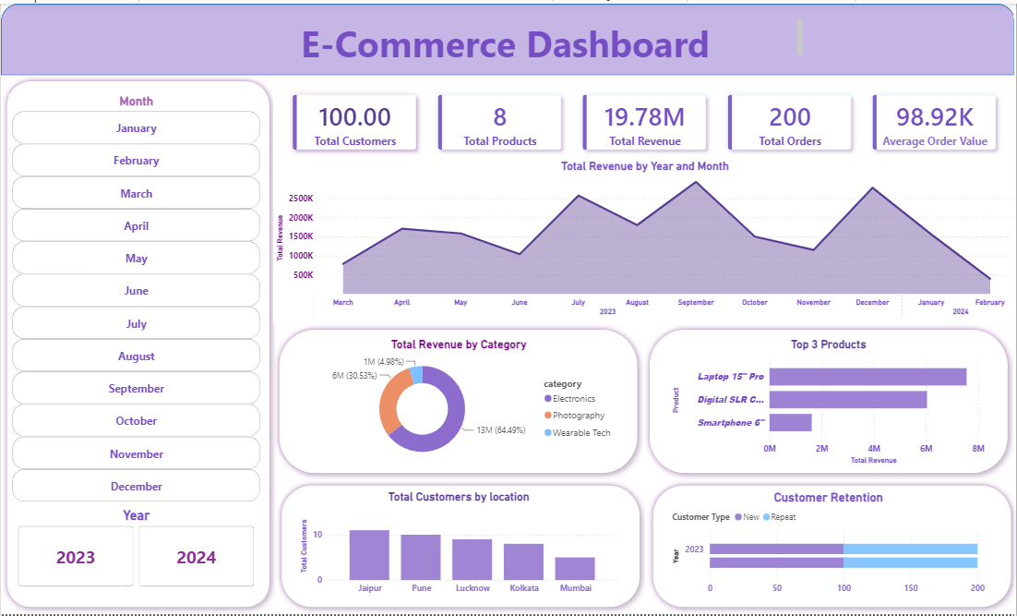

Business Strategy Recommendations
Business Recommendation: Focus on retention, bundling, and seasonal planning as the core growth strategy. Use customer segmentation for targeted campaigns, improve cross-sell opportunities through product bundles, maintain stronger stock for fast-moving items, and run aggressive promotions during low-demand months to stabilize sales.

